2016June20 Trading

Monday:

Focus on PMCL trading.

Find out which are the most tradable scenarios.

Find out what time to start buying in the AM. (Surmise to be 11:15ish)

Tuesday:

Due to yesterday’s strong PM session, this PM failed to perform. The short was well done at the beginning of the day. Closed right at the lows with no rebound. Position is 30 bps under water.

AM started with a trap which lured investors to follow. Once the trap is set up, markets started to slide. The short was covered quickly

The strategy dictates long when Monday PM < -0.005. So today’s PM trading is actually a violation of the trading strategy.

Weekly:

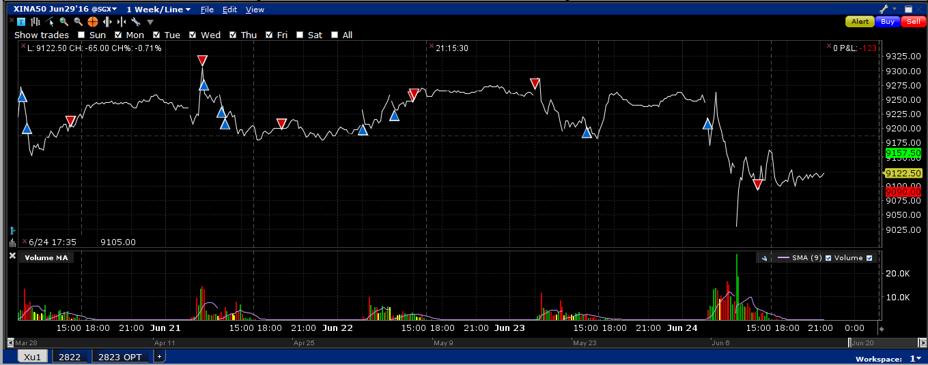

Overall: Monday, Tues, Thurs, Fri qualified for Am shorting.

Mon, Wed, Fri qualified for PM long.

Mon ( short AM, long PM).

Tue: short whole day.

Wed: long whole day.

Thur: short whole day.

Fri: short AM, long PM.

Monday: The buy was too early. Should wait until the afternoon.

Tue: Short was well done. Covered a bit too early. Afternoon there was no rebound. (Monday pm was positive)

Wed: Bought at the early open (good trade) added position in the pm – good.

Thurs: Due to a strong Wednesday , short position was put on at the beginning of the market.

Fri: Britain exited Euro. Bought future at 903am because markets were expecting a Bremain. As it became more obvious that it would be exit, markets panicked. Sold the position at 1455.

Overall: Light positioning in the AM. PM offers advantage.

Some lessons:

Sharpe ratio (risk adjusted return) is more important than return. Using leverage, one can achieve the same expected return at the lowest variance. The most efficient trading strategy is the one with the highest sharpe. The ability to scale up on a position on a big Sharpe is crucial.

Monday was up, Tuesday PM distribution then shift to the negative region. The fact that it didn’t rebound is a sign of weakness.